**Siddhant mundhe**

**Data engineering bacth 1**

**Day 2 assignment**

**OLTP**

* OLTP stands for "Online Transaction Processing." Imagine you're running a business, like a store. Every time a customer buys something, you need to record that transaction, update inventory, and make sure the customer's account reflects the purchase.
* OLTP is like the behind-the-scenes system that helps you handle these transactions quickly and efficiently. It's all about processing a large number of short, quick transactions in real-time. So, every time someone buys a product in your store, OLTP ensures that the inventory is updated, the sale is recorded, and everything happens instantly.

**OLAP**

* OLAP stands for Online Analytical Processing. Imagine you run a big store, and you want to analyze your sales data to make strategic decisions. You have a ton of information about what products are selling well, which regions are performing better, and so on.
* OLAP is like the tool that helps you analyze and understand all this data easily. It's designed for complex queries and reporting. So, if you want to know things like the total sales of a product category in a specific region over the last year, OLAP helps you quickly get that information.

**RDBMS**

* RDBMS stands for "Relational Database Management System.
* Let's break it down in a simple way:

1. Database: Think of it as a digital filing cabinet where you can store and organize information.
2. Relational: This refers to the way the data is organized. Imagine you have two types of information, like "Customers" and "Orders." A relational database establishes a relationship between them.
3. Management System: It's like the software that helps you interact with and manage the data in your database.

* Example: Imagine you have a business selling books. You can create two tables in an RDBMS - one for customers and one for orders.
* Several popular relational database management systems (RDBMS) are widely used in the industry. Here are some examples: MySQL, PostgreSQL, Microsoft SQL Server, Oracle Database, SQLite, IBM Db2.

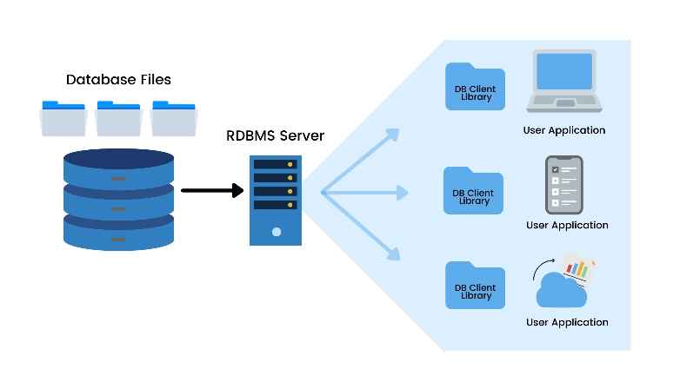

Fig. RDBMS Architecture

**SQL**

* Stands for Structured Query Language, is a language used for managing and manipulating relational databases.
* Here are some key features of MySQL:

1. Open Source: MySQL is freely available and open-source, making it accessible to a wide range of users without licensing costs.
2. Cross-Platform Compatibility: MySQL is designed to run on various operating systems, including Windows, Linux, macOS, and more.
3. Scalability: MySQL is scalable, allowing for efficient handling of both small and large databases. It can handle high-volume transactions and data.
4. High Performance: MySQL is known for its speed and performance, making it suitable for applications that require quick and efficient data retrieval.
5. ACID Compliance: MySQL ensures ACID (Atomicity, Consistency, Isolation, Durability) compliance, which guarantees the reliability of database transactions.